CHAPTER 1
INTRODUCTION

INTRODUCTION

As cyber threats grow in complexity and frequency, organizations must adopt proactive and automated security strategies to safeguard their digital assets. Traditional Security Operations Centers (SOCs) often rely on manual processes for threat detection and incident response, which can lead to delayed reactions, increased false positives and analyst fatigue. To address these challenges, this project explores the integration of two open-source platforms—Wazuh and Shuffle—to build a real-time, automated threat monitoring and response system.

Complementing Wazuh, Shuffle acts as a low-code Security Orchestration, Automation and Response (SOAR) engine. It enables the creation of modular workflows that automate repetitive tasks such as alert enrichment, threat intelligence lookups and remediation actions. By integrating Shuffle with Wazuh’s alerting pipeline, the system can respond to threats in real time—executing predefined playbooks that isolate compromised assets, notify stakeholders and initiate recovery procedures.

Wazuh serves as the backbone of the monitoring infrastructure, offering comprehensive capabilities in log aggregation, file integrity monitoring, intrusion detection, vulnerability assessment and compliance reporting. It collects and analyzes data from endpoints, servers, cloud workloads and network devices, generating alerts based on customizable rules and threat signatures.

This project aims to demonstrate how open-source tools can be orchestrated to deliver enterprise- grade security automation with minimal overhead. The architecture emphasizes scalability, modularity and transparency, allowing security teams to adapt workflows to evolving threat landscapes. Key components include RESTful API integrations, real-time dashboards and approval gates to ensure human oversight in critical response actions.

Through simulated attack scenarios and performance benchmarks, the project validates the system’s ability to detect threats, reduce response latency and improve operational efficiency. The outcome is a robust framework that enhances an organization’s cybersecurity posture while reducing manual workload and accelerating incident resolution.

OBJECTIVE:

In today’s rapidly evolving cyber threat landscape, organizations require robust, scalable and automated solutions to detect, analyze and respond to security incidents in real time. This project aims to design and implement an integrated Security Information and Event Management (SIEM) and Security Orchestration, Automation and Response (SOAR) framework using Wazuh and Shuffle, enabling proactive threat monitoring and automated incident response.
The primary objective is to build a cost-effective, open-source-driven security operations solution that empowers security teams to detect anomalies, correlate events across distributed systems and initiate timely responses with minimal human intervention. Wazuh, a powerful SIEM platform, will serve as the core for log collection, threat detection, file integrity monitoring and compliance auditing. It will be configured to ingest logs from multiple endpoints, servers and cloud services, normalizing and analyzing them in real time using rule-based detection mechanisms.
To complement Wazuh’s detection capabilities, Shuffle will be integrated as the SOAR layer to automate incident response workflows. Shuffle’s low-code/no-code interface allows for the creation of dynamic playbooks that can trigger actions such as isolating compromised hosts, sending alerts to security analysts, updating ticketing systems, or even blocking malicious IPs via firewall APIs. This integration ensures that once a threat is detected by Wazuh, Shuffle can immediately act upon it, reducing mean time to respond (MTTR) and minimizing potential damage.
The project will also focus on building a modular and extensible architecture that supports scalability and customization. Key components include:
- Log Forwarding & Parsing: Using agents like Wazuh and Filebeat to forward logs from endpoints and cloud services.
- Threat Intelligence Integration: Enriching alerts with external threat feeds (e.g., AbuseIPDB, VirusTotal).
- Custom Detection Rules: Tailoring Wazuh rules to detect specific attack patterns such as brute- force attempts, privilege escalation, or lateral movement.
- Automated Playbooks: Designing Shuffle workflows for common incident types (e.g., malware detection, unauthorized access, suspicious outbound traffic).
- Dashboarding & Alerting: Visualizing security events via Kibana and configuring alert thresholds for critical incidents.
By the end of the project, the system will be capable of:
- Real-time detection of security threats across heterogeneous environments.
- Automated triage and response actions based on predefined playbooks.
- Centralized visibility into security posture with actionable insights.
- Reduced analyst fatigue through automation of repetitive tasks.
This solution not only demonstrates the power of open-source tools in building enterprise- grade security infrastructure but also provides a practical, hands-on framework for organizations seeking to enhance their cyber resilience. It serves as a blueprint for integrating detection and response capabilities in a cohesive, automated and intelligent manner.

CHAPTER 2

LITERATURE REVIEW
  - Existing Survey:

TITLE: AUTOMATED DEFENSE AGAINST APPLICATION-LAYER ATTACKS ON WINDOWS SYSTEMS USING WAZUH AND SHUFFLE
AUTHORS: AASTHA THAKKER, KAPIL KUMAR, 2025

Application-layer attacks targeting Windows systems remain a significant threat due to their ability to bypass traditional perimeter defenses. These attacks often exploit vulnerabilities listed in the OWASP Top 10 for desktop applications, demanding proactive defense mechanisms. This paper proposes a unified approach that combines SIEM and SOAR capabilities to detect and respond to Windows-based application-layer threats with increased efficiency and automation. The framework integrates the open-source SIEM platform Wazuh with the SOAR engine Shuffle to automate threat detection and incident response.

TITLE: SECURITY AND THREAT DETECTION THROUGH CLOUD-BASED
WAZUH DEPLOYMENT
AUTHORS: SYED MOIZ, ABDUL MAJID, 2024

This research emphasizes the critical need to safeguard organizational assets from cyber threats and highlights the pivotal role that firewalls play in fortifying network and cyber systems. The challenge lies in maintaining updated firewall defenses to prevent server downtime and the circumvention of security measures. To address these concerns, this study introduces a novel approach by integrating Cloud Wazuh, a user-friendly solution tailored for non-technical personnel, providing streamlined deployment and customizable security rules. Leveraging Wazuh suite of tools, particularly the Host- Based Intrusion Detection System (HIDS), the research detects and mitigates potential threats, including patterns associated with attacks such as Port Scanning, Denial of Service (DoS) and Metasploit.

TITLE: IMPROVING THREAT DETECTION IN WAZUH USING MACHINE LEARNING TECHNIQUES
AUTHORS: SAMIR ACHRAF CHAMKAR, MOUNIA ZAYDI, 2025

The escalating complexity, frequency and scale of cyber threats present growing challenges to the effectiveness of traditional Security Operations Centers (SOCs). As cyberattacks evolve beyond signature-based exploits to include sophisticated, stealthy and adaptive techniques, SOCs must adopt intelligent, scalable and real-time threat detection mechanisms to maintain organizational resilience and response capability. Wazuh, a widely adopted open-source Security Information and Event Management (SIEM) system, plays a central role in providing security visibility through the
collection and correlation of logs, intrusion alerts and system anomalies across distributed infrastructure.

TITLE: REAL-TIME DEFENSEAGAINSTCYBER THREATS: ANALYZING WAZUH'S EFFECTIVENESS IN SERVER MONITORING
AUTHORS: ALDE ALANDA, H.A MOODUTO, RONAL HADI, 2023

As cloud computing grows exponentially, organizations face escalating cybersecurity challenges due to increased cyber threats and attacks on cloud-based networks. Monitoring cloud servers is one action that can be taken to improve the security. This can be done with the help of various server monitoring tools, such as Wazuh. The study investigates Wazuh's effectiveness in real-time monitoring of three AWS EC2 instance-based cloud servers. Wazuh's capabilities such as log data collection, malware detection, active response automation and Docker container monitoring, are examined

TITLE: SIEM AND THREAT INTELLIGENCE: PROTECTING APPLICATIONS WITH WAZUH AND THEHIVE
AUTHORS:JUMIATY, BENFANO SOEWITO

This paper explores the use of Wazuh in conjunction with TheHive for application-level threat detection. It emphasizes the importance of real-time alerting and correlation of events across distributed systems. While Shuffle is not directly used, the study lays foundational insights into integrating SIEM with SOAR platforms for automated response

TITLE: SECURITY OPERATIONS CENTER USING OPEN-SOURCE TOOLS
AUTHORS: KUNAL WALAVALKAR, KEDAR WALAVALKAR, YASH J
AGDALE, 22024

This research presents a full-stack open-source SOC architecture using Wazuh, Shuffle, TheHive and Cortex. It details the deployment pipeline, alert triaging and response orchestration. The paper highlights Shuffle’s role in automating playbooks triggered by Wazuh alerts, showcasing a practical implementation of real-time threat response.

CHAPTER 3 SYSTEM ANALYSIS

Existing System:
The existing system relies on manual log analysis, isolated security tools and delayed incident response, making it inefficient against modern cyber threats. Logs are scattered across endpoints with no centralized SIEM and alerts often lack context due to missing threat intelligence. Response actions are manual, increasing mean time to detect and respond. There's limited scalability, no automation and high analyst fatigue due to repetitive tasks and alert overload. Without orchestration, security operations remain reactive and fragmented. This setup fails to meet compliance standards and leaves organizations vulnerable to multi-stage attacks, data breaches and operational disruption. A smarter, automated solution is needed.

Drawbacks:

Manual Response Workflow
Security analysts must manually investigate and respond to alerts, leading to delays and inconsistent remediation.

Lack of Centralized Visibility
Logs and events are scattered across endpoints, making it difficult to correlate incidents and detect multi-stage attacks.

No Real-Time Detection
Traditional systems often process logs in batches, resulting in delayed threat identification and slower response times.

High Alert Fatigue
Excessive false positives overwhelm analysts, reducing efficiency and increasing the risk of missing critical threats.

Limited Scalability
Adding new devices or services requires manual configuration, making it hard to adapt to growing infrastructure.

No Threat Intelligence Integration
Alerts lack enrichment from external sources, reducing context and accuracy in threat classification

Proposed System:
The proposed system integrates Wazuh (SIEM) and Shuffle (SOAR) to deliver a real-time, automated threat monitoring and response framework. Wazuh collects and analyzes logs from endpoints, servers and cloud services, detecting anomalies using custom rules and threat intelligence feeds. Shuffle complements this by executing automated playbooks that isolate threats, notify analysts and trigger remediation actions. This integration reduces response time, enhances visibility and minimizes manual effort. The system is scalable, open-source and tailored for proactive security operations. It empowers organizations to detect, correlate and respond to threats swiftly while maintaining compliance and operational resilience across diverse environments.

Advantages:

Real-Time Threat Detection
Wazuh continuously monitors logs and system activity, enabling immediate identification of suspicious behavior and anomalies.

Automated Incident Response
Shuffle executes predefined playbooks to respond to threats instantly—isolating hosts, sending alerts, or blocking IPs without manual intervention.

Centralized Visibility
Security events from multiple sources are aggregated and visualized in a unified dashboard, improving situational awareness.

Scalability & Flexibility
The open-source architecture supports easy integration with new endpoints, cloud services and custom rules.

Reduced Analyst Workload
Automation minimizes repetitive tasks and false positives, allowing analysts to focus on critical threats.

Improved Compliance & Reporting
Built-in auditing and alerting features help meet regulatory requirements and generate actionable reports.

CHAPTER 4 SPECIFICATION

Hardware Requirements:

Processor (CPU)
Minimum: Quad-core @ 2.0 GHz
Recommended: Octa-core @ 2.5 GHz or higher for faster log processing and response execution.

Memory (RAM)
Minimum: 8 GB
Recommended: 16–32 GB to support Elasticsearch indexing and concurrent playbook execution.

Storage
Minimum: 100 GB SSD
Recommended: 250 GB SSD/NVMe with expandable capacity for log retention and backups.

Network
1 Gbps Ethernet with static IP; essential for agent-server communication and API integrations.

Power Supply & Backup
Standard 400W PSU; optional RAID or cloud backup for data resilience.

Virtualization Support
Compatible with VirtualBox, VMware, or Docker for isolated and scalable deployments.

Software Requirements:

Operating System
Server: Ubuntu 20.04 LTS or later
Client/Agents: Windows, Linux, or macOS (for endpoint monitoring)

Core Platforms
Wazuh: SIEM platform for log collection, threat detection and compliance auditing Shuffle: SOAR platform for building and executing automated incident response playbooks.

Supporting Tools
Elasticsearch: Stores and indexes security events Kibana: Visualizes alerts and dashboards Filebeat (optional): For log forwarding
Nginx/Apache: Web server for hosting dashboards

Programming & Scripting
Python: For custom Shuffle workflows YAML/JSON: For Wazuh rule configuration Bash/Shell: For automation and deployment scripts.

Browser Compatibility
Chrome, Firefox, Edge (for accessing Kibana and Shuffle UI)

APIs & Integrations
AbuseIPDB, VirusTotal (for threat intelligence enrichment) Optional firewall/EDR integrations via Shuffle plugins.

CHAPTER 5 PROJECT DESCRIPTION

Problem Definition:
In today’s cybersecurity landscape, organizations face a constant barrage of threats ranging from malware and phishing to insider attacks and advanced persistent threats. Traditional security monitoring systems often rely on manual processes and fragmented tools, resulting in delayed detection, inefficient response and increased risk exposure. Security teams struggle to manage high volumes of alerts, many of which are false positives, while lacking the automation needed to respond swiftly and effectively.
Wazuh, an open-source SIEM and XDR platform, offers robust capabilities for log collection, rule-based threat detection and alert generation. However, it lacks native automation for incident response, which is critical for minimizing damage and reducing response time. Shuffle, a low-code SOAR platform, addresses this gap by enabling automated workflows triggered by alerts. It integrates with threat intelligence services, notification channels and case management tools to streamline and accelerate response actions.
The core problem this project addresses is the absence of a unified, real-time threat monitoring and response system that combines detection, enrichment and remediation. By integrating Wazuh and Shuffle, the system aims to provide continuous monitoring of endpoints and networks, generate actionable alerts and execute automated workflows for threat containment and resolution.
This solution reduces manual workload, improves response speed and enhances overall security posture. It is especially valuable for organizations seeking scalable, open-source alternatives to commercial SIEM/SOAR platforms. The project also lays the foundation for future enhancements such as machine learning-based anomaly detection and advanced behavioral analytics.

Flow Chart:

Wazuh Agent
Wazuh Manager
Kibana
Endpoint Logs
Shuffle SOAR
Automated Response Playbooks

Figure 5.1

Overview of the Project:

This project focuses on building a real-time cybersecurity framework by integrating Wazuh (SIEM) and Shuffle (SOAR) to detect, analyze and respond to threats across distributed systems. Wazuh collects and correlates logs from endpoints, servers and cloud services, identifying anomalies using rule-based detection and threat intelligence feeds. Shuffle automates the response process through dynamic playbooks that isolate compromised assets, notify analysts and trigger remediation actions. The system enhances visibility, reduces response time and minimizes manual effort. It offers a scalable, open-source solution tailored for proactive security operations, compliance management and operational resilience in modern IT environments.

Internet
Logs
Event
Shuffle
Wazuh
Send Alert &
Response

Figure 5.2
PC

MODULE DESCRIPTION:
The project consists of modules for log collection, threat detection and automated response. Wazuh handles SIEM tasks like log parsing, rule-based alerting and compliance checks. Shuffle manages SOAR workflows, executing playbooks for incident response. Together, they provide centralized monitoring, real-time detection and scalable automation across diverse IT environments.

Block Diagram:
Threat Detection
Log Collection
Alert Visualization
Incident Remediation
Automated Response

Compliance & Reporting
Figure 5.3

5.4 Working:
Step 1: Log Collection
Purpose: To gather system activity and security-related data from endpoints and servers. Function: Wazuh agents are deployed on devices to collect logs such as authentication attempts, file changes and network activity. These logs are forwarded to the Wazuh manager for centralized processing.

Step 2: Threat Detection
Purpose: To identify suspicious behavior and potential security incidents in real time. Function: Wazuh analyzes incoming logs using rule-based detection and threat intelligence feeds. Alerts are generated for anomalies like brute-force attacks, privilege escalation, or malware indicators.

Step 3: Alert Visualization
Purpose: To provide security analysts with clear, actionable insights into system threats. Function: Kibana dashboards display alerts, trends and system health metrics. Analysts can filter, investigate and correlate events across multiple sources.

Step 4: Automated Response
Purpose: To reduce response time and minimize manual intervention during incidents. Function: Shuffle triggers playbooks based on Wazuh alerts. These workflows can isolate compromised hosts, send notifications, block IPs, or update ticketing systems automatically.

Step 5: Incident Remediation
Purpose: To contain and resolve threats efficiently with minimal disruption.
Function: Shuffle executes remediation actions such as disabling user accounts, restarting services, or applying patches. All actions are logged and tracked for audit purposes.

Step 6: Compliance & Reporting
Purpose: To ensure regulatory compliance and maintain security documentation. Function: Wazuh and Shuffle generate audit-ready reports, track incident metrics (MTTD, MTTR) and support standards like GDPR, HIPAA and ISO 27001.

CHAPTER 6
WAZUH: ARCHITECTURE AND CAPABILITIES

Overview:
Wazuh is an open-source security information and event management (SIEM) platform that provides log analysis, intrusion detection, vulnerability detection and compliance monitoring. It integrates seamlessly with the Elastic Stack for data indexing and visualization, making it a powerful tool for real-time threat monitoring.

Core Components of Wazuh Architecture:

Component | Description
Wazuh Agent | Installed on endpoints to collect system logs, monitor file integrity and detect anomalies.
Wazuh Manager | Central server that receives data from agents, applies rules and generates alerts.
Wazuh API | RESTful interface for querying alerts, agent status and system metrics.
Elastic Stack | Includes Elasticsearch (data indexing), Logstash (data processing) and Kibana (visualization).
Filebeat | Lightweight shipper that forwards logs to Logstash  or Elasticsearch.
Table 6.1

Data Flow and Alert Lifecycle:
- Log Collection: Wazuh agents collect logs from operating systems, applications and network devices.
- Data Transmission: Logs are securely sent to the Wazuh Manager.
- Rule Evaluation: The Manager applies pre-defined and custom rules to detect threats.
- Alert Generation: Alerts are created based on rule matches and forwarded to the Elastic Stack.
- Visualization: Kibana dashboards display alerts, trends and system health metrics.

Key Capabilities:

Log Analysis
    - Parses logs from multiple sources including syslog, Windows Event Logs and cloud services.
    - Supports custom decoders and rules for tailored threat detection.

Intrusion Detection
    - Detects brute-force attacks, privilege escalation and suspicious behavior.
    - Integrates with threat intelligence feeds for IOC matching.

Vulnerability Detection
    - Scans systems for known vulnerabilities using CVE databases.
    - Provides detailed reports for patch management.

File Integrity Monitoring (FIM)
    - Tracks changes to critical files and directories.
    - Alerts on unauthorized modifications or deletions.

Compliance Monitoring
    - Supports PCI DSS, GDPR, HIPAA and other regulatory frameworks.
    - Generates audit-ready reports and dashboards.

Real-Time Alerting
    - Alerts are enriched with metadata and severity levels.
    - Can be forwarded to external systems via email, webhook, or API.

Scalability and Extensibility
    - Supports distributed deployments with thousands of agents.
    - Easily integrates with SOAR platforms like Shuffle for automated response.
    - Offers modular configuration for custom use cases.

CHAPTER 7
SHUFFLE: WORKFLOW AUTOMATION AND INTEGRATION

Overview:
Shuffle is an open-source Security Orchestration, Automation and Response (SOAR) platform designed to streamline incident response through visual workflows. It enables security teams to automate repetitive tasks, integrate tools via APIs and respond to threats in real time with minimal manual intervention.

Core Features of Shuffle:

Feature | Description
Visual Workflow Editor | Drag-and-drop interface for building playbooks without coding.
App  Integrations | Supports REST APIs, Python scripts and prebuilt connectors for  tools like Wazuh, Slack, Jira, etc.
Trigger- Based Execution | Workflows can be triggered by alerts, webhooks, or scheduled intervals.
Conditional  Logic | Enables branching decisions based on alert severity, source, or  type.
Parallel  Execution | Supports concurrent actions to reduce response time.
Audit  Logging | Tracks workflow execution for compliance and debugging.

Table 7.1

Integration with Wazuh:

API Connectivity
    - Shuffle connects to the Wazuh API using REST calls.
    - Authentication is handled via API keys or basic auth.
    - Alerts from Wazuh are ingested into Shuffle as JSON payloads.

Workflow Triggering
    - Alerts from Wazuh (e.g., brute-force login, file tampering) trigger Shuffle workflows.
    - Webhooks or polling mechanisms are used to detect new alerts.

Response Actions
    - Based on alert type and severity, Shuffle can:
    - Send notifications via Slack, email, or Microsoft Teams
    - Create incident tickets in Jira or ServiceNow
    - Execute remediation scripts (e.g., block IP, disable user account)
    - Enrich alerts with threat intelligence (e.g., VirusTotal, AbuseIPDB)

Sample Workflow Structure:

[Trigger: Wazuh Alert] → [Filter: Severity > 7] → [Enrich: IP Reputation] → [Notify:
Slack] → [Create Ticket: Jira] → [Remediate: Block IP]

Each block represents a modular action that can be reused across multiple workflows.

Benefits of Using Shuffle:
    - Speed: Reduces response time from minutes to seconds.
    - Consistency: Ensures standardized handling of incidents.
    - Scalability: Handles multiple alerts and workflows simultaneously.
    - Flexibility: Easily integrates with new tools and APIs.
    - Transparency: Provides clear audit trails for every action taken.

Challenges and Mitigations:
    - API Rate Limits: Managed by batching requests and using retries.
    - Alert Noise: Mitigated by filtering low-severity alerts and tuning Wazuh rules.
    - Workflow Complexity: Addressed through modular design and document

CHAPTER 8 SYSTEM DESIGN

System Architecture

This section breaks down the internal components, data flow and integration logic that
power the real-time threat monitoring system.

Component Overview:

Wazuh Agent | Collects logs and telemetry from endpoints
Wazuh Manager | Parses logs, applies rules, generates alerts
Elasticsearch | Stores alerts and logs for search and analysis
Kibana | Visualizes threat data and system health
Shuffle SOAR | Automates response workflows based on Wazuh alert
External Services | Threat intel (VirusTotal), ticketing (Jira), messaging (Slack)

Table 8.1

Data Flow Design:

[Endpoint] → [Wazuh Agent] → [Wazuh Manager] → [Elasticsearch] → [Kibana]
↓
[Shuffle SOAR]
↓
[Automated Response Actions] Step 1: Logs from endpoints are collected by Wazuh agents.
Step 2: Wazuh Manager applies detection rules and forwards alerts to Elasticsearch. Step 3: Shuffle listens for new alerts via API/webhook and triggers playbooks.
Step 4: Playbooks execute automated actions (e.g., notify, isolate, enrich).

Integration Design:

Integration point | Method | Purpose
Wazuh → Elasticsearch | Native integration | Log indexing and alert storage
Wazuh → Shuffle | REST API / Webhook | Alert ingestion and playbook trigger
Shuffle → Slack/Jira | API connectors | Notifications and ticketing
Shuffle → Threat Intel | API (e.g., VirusTotal) | IOC enrichment
Table 8.2

Playbook Logic (SOAR):

Each playbook in Shuffle follows a modular logic:
Trigger
Enrich
Filter

Log
Notify
Act
Figure 8.1

Trigger:
Wazuh alert received

Filter:
Check severity, source, or rule ID

Enrich:
Query threat intel APIs

Act:
Block IP, isolate host, update firewall

Notify:
Send Slack/email alert

Log:
Store response metadata in Elasticsearch

Scalability & Fault Tolerance

Horizontal Scaling:
Wazuh agents and Shuffle workers can scale independently

Queueing:
Shuffle uses internal queues to manage playbook execution

Retry Logic:
Failed API calls are retried with exponential backoff.

Monitoring:
Kibana dashboards track alert volume, playbook success and system health.

Security Design

    - TLS encryption between all components
    - Role-based access control in Wazuh and Shuffle
    - API keys securely stored and rotated
    - Audit logging of all actions and playbook executions

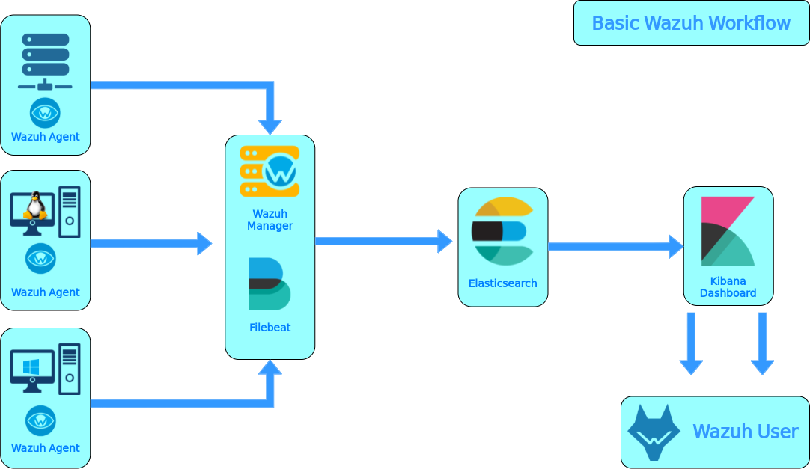

Figure 8.2

CHAPTER 9 IMPLEMENTATION

Environment Setup
  - Operating System: Ubuntu Server 20.04 LTS (or compatible Linux distro)

Wazuh Deployment:
  - Installed Wazuh Manager, Wazuh API and Wazuh Agent
  - Configured Elastic Stack (Elasticsearch, Logstash, Kibana) for log indexing and visualization

Shuffle Deployment:
  - Installed Shuffle on Docker or Kubernetes
  - Enabled integrations with Wazuh API, Slack, email and other response tools

Log Collection & Agent Configuration
- Wazuh Agents installed on endpoints (Linux/Windows) to collect:
- System logs
- Authentication events
- File integrity monitoring (FIM)
- Rootkit detection and vulnerability scans

Agent Registration:
- Registered agents with Wazuh Manager
- Verified heartbeat and log flow

Rule Tuning & Alert Generation
- Customized Wazuh rules to detect:
- Brute-force login attempts
- Suspicious file changes
- Privilege escalation
- Malware signatures
- Set alert levels and thresholds to reduce false positives
- Enabled email and webhook notifications for critical alert.

Shuffle Workflow Design
Created automated workflows triggered by Wazuh alerts:

Input:
Wazuh alert via webhook or API

Processing:
Conditional logic to filter severity, enrich with threat intelligence.

Response Actions:
  - Send alert to Slack or email
  - Create incident ticket in Jira or ServiceNow
  - Run remediation script (e.g., block IP, disable user)
  - Used Shuffle’s visual editor to design and test workflow

Integration & API Connectivity
  - Connected Wazuh API to Shuffle using REST calls
  - Verified JSON payload structure and authentication headers
  - Enabled bidirectional communication for alert ingestion and response execution

Dashboard & Visualization
  - Configured Kibana dashboards to display:
  - Alert trends over time
  - Top offending IPs and users
  - System health and agent status
  - Created custom visualizations for SOC monitoring

Testing & Validation
  - Simulated attack scenarios using tools like Metasploit and custom scripts
  - Verified detection by Wazuh and automated response by Shuffle
  - Logged and analyzed response time, accuracy and system load.

Step 1: Install Wazuh Server Using Quick Start
Download and run the Wazuh installation assistant.

curl -sO https://packages.wazuh.com/4.10/wazuh-install.sh && sudo bash ./wazuh-install.sh -a

Once the assistant finishes the installation, the output shows the access credentials and a message that confirms that the installation was successful.

INFO: --- Summary ---
INFO: You can access the web interface
https://<WAZUH_DASHBOARD_IP_ADDRESS>
User: admin
Password: <ADMIN_PASSWORD>

INFO: Installation finished.
- You now have installed and configured Wazuh.
Access the Wazuh web interface with https://<WAZUH_DASHBOARD_IP_ADDRESS> and your credentials:
- Username: admin
- Password: <ADMIN_PASSWORD>

Step 2: Onboard an Ubuntu Machine as a Wazuh Agent

Access the Wazuh web interface with
https://<WAZUH_DASHBOARD_IP_ADDRES>
and your credentials:
  - Username: admin
  - Password: <ADMIN_PASSWORD>

Click on 3 lines at the top left corner besides 'w' symbol
  - Navigate to Agents Management
  - Go to Summary and Deploy New Agent
  - Navigate to Linux > DEB amd64
  - Under Server address mention Wazuh Server IP address
  - You will get a command to install Wazuh Agent , copy it and paste on Ubuntu Agent.
  - Start the agent by running below command sudo systemctl daemon- reload

sudo systemctl enable wazuh- agent sudo systemctl start wazuh-agent

Step 3: Verify Agent Connection in Wazuh Dashboard
- Open Wazuh Dashboard (https://<Wazuh-Server-IP).
- Navigate to "Agents" in the Wazuh UI.
- Check if the Ubuntu agent is listed as "Active".

Step 4: Integrating Wazuh with Shuffle
  - Enable Remote Logging in shuffle
  - Log in to the pfSense Web GUI.
  - Go to Status → System Logs → Settings
  - Under General Logging Options → Log Message Format
→ Select syslog
  - Scroll down to Remote Logging Options.
  - Check “Send log messages to remote syslog server”.
  - In the Remote Syslog Servers field, enter your Wazuh
server’s IP and port
  - Under Remote Syslog Contents, check at least:
  - System events
  - DHCP, VPN, or other categories you want to monitor
  - Save the changes.

Step 5: Configure Wazuh to recieve logs from syslog
  - ssh into Wazuh server
  - Run below commands to add custom decoder for processing pfSense firewall logs

sudo nano /var/ossec/etc/decoders/local_decoder.xml
<decoder name=" shuffle -filterlog">
<prematch>filterlog:</prematch>
<program_name>filterlog</program_name>
<type>syslog</type>
</deco der> save and exit

  - Make sure to enable json logs under ossec.conf sudo nano
/var/ossec/etc/ossec.conf
<ossec_config>
<global>
<logall>yes</logall>
<logall_json>yes</logall_json>
</global>

CHAPTER 10
USE CASE SCENARIOS AND RESPONS WORKFLOWS

Malware Execution Detection
  - Trigger: Sysmon detects suspicious process creation (e.g., , )
  - Wazuh Rule: Custom rule matches known malware signatures or behavior

Shuffle Workflow:
  - Parse alert details
  - Notify SOC via Slack/Email
  - Create case in TheHive
  - Optionally isolate host via EDR API

Unauthorized File Access
  - Trigger: File access to sensitive directories by non-admin users
  - Wazuh Rule: Monitors audit logs for access violations

Shuffle Workflow:
  - Log incident in ticketing system (e.g., Jira)
  - Send alert to data owner
  - Trigger forensic script to collect file access logs

Brute Force Login Attempts
  - Trigger: Multiple failed SSH login attempts from same IP
  - Wazuh Rule: Aggregates failed login events over time

Shuffle Workflow:
  - Block IP via firewall API
  - Notify admin
  - Add IP to threat intel list

Suspicious Network Activity
  - Trigger: Unusual outbound traffic (e.g., to known C2 domains)
  - Wazuh Rule: Matches against threat intel feeds

Shuffle Workflow:
  - Enrich alert with WHOIS and geolocation
  - Create case in TheHive
  - Trigger packet capture on affected host

Privilege Escalation Attempt
  - Trigger: Use of or by unauthorized user
  - Wazuh Rule: Detects elevation attempts outside approved roles

Shuffle Workflow:
  - Alert SOC
  - Suspend user account via IAM API
  - Generate audit report

Response Workflow Blueprint

Wazuh → Shuffle Integration
  - Wazuh sends alerts via webhook to Shuffle
  - Shuffle parses JSON payload and triggers matching workflow

Shuffle Workflow Logic
Trigger: Wazuh alert received
↓
Condition: Alert level ≥ 10 AND rule ID matches known threat
↓
Actions:
- Notify SOC (Slack, Email)
- Enrich alert (VirusTotal, WHOIS, GeoIP)
- Create case (TheHive, Jira)
- Execute response (EDR, IAM, Firewall)
- Log action (SIEM, ticketing)

Example:
Mimikatz Detection Workflow
- Wazuh detects mimikatz.exe via Sysmon
- Sends alert to Shuffle webhook
- Shuffle:
  - Parses alert
  - Queries VirusTotal for hash reputation
  - Sends Slack alert to SOC
  - Creates case in TheHive
  - Isolates host via CrowdStrike API
  - Logs response in Jira

Tools You Can Integrate with Shuffle

Tool | Purpose
TheHive | Case management
Slack/Email | SOC notifications
Jira | Ticketing and audit trail
CrowdStrike | Host isolation
Virus Total | Threat enrichment
AWS IAM | User suspension
Palo Alto FW | IP blocking

Table:10.1
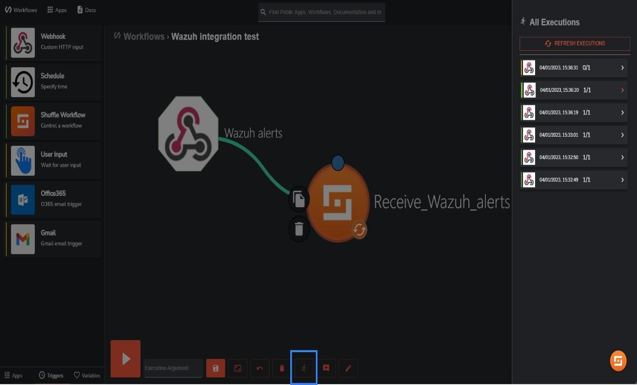
Figure 10.1

CHAPTER 11 TESTING AND VALIDATION

Testing Strategy Overview:

Phase | Purpose | Tools Involved
Unit Testing | Validate individual Wazuh rules and Shuffle action | Wazuh test rules, Shuffle test triggers
Integration Testing | Ensure Wazuh alerts trigger correct Shuffle workflow | Wazuh + Shuffle
Functional Testing | Simulate real-world attack scenarios | Atomic Red Team, Caldera
Regression Testing | Confirm updates  don’t break existing workflows | Git + CI/CD (optional)
Performance Testing | Measure alert-to- response latency | Custom timers, logs
User Acceptance Test | Validate with SOC analysts | Manual review

Table 11.1

Wazuh Rule Testing

1: Simulated Log Injection
    - Use logger or echo to inject test logs into /var/ossec/logs/active-responses.log or monitored files.

Example:
logger "Failed password for invalid user root from 192.168.1.100"

2: Wazuh Test Rules
    - Use wazuh-logtest to validate rule matching:
/var/ossec/bin/wazuh-logtest

> Enter log to test: Failed password for invalid user root from 192.168.1.100

Validation Criteria
    - Rule ID is triggered
    - Alert level is appropriate
    - Fields (srcip, user, rule.id) are correctly parsed

Shuffle Workflow Testing Manual Trigger
  - Use Shuffle’s UI to manually trigger workflows with sample payloads.

Validate:
  - Correct branching logic
  - API calls (e.g., to TheHive, Slack, firewall)
  - Error handling and retries

Webhook Simulation
  - Use curl to simulate Wazuh alert

curl -X POST -H "Content-Type: application/json" -d @sample_alert.json http://<shuffle_url>/api/v1/hooks/<workflow_id>

Assertions
  - Workflow completes without error
  - All intended actions are executed
  - Logs show expected outputs

End-to-End Attack

Simulation Use tools like:
  - Atomic Red Team: Run specific TTPs (e.g., credential dumping, lateral movement)
  - MITRE Caldera: Emulate adversary behavior across kill chain
  - Manual Tests: Trigger brute force, privilege escalation, or malware execution

Validation Checklist

Component | Expected Outcome
Wazuh | Alert generated with correct rule ID & field
Shuffle | Workflow triggered and complete
External APIs | Actions executed (e.g., IP blocked, case created
Logs | No errors, timestamps align
Table 11.2

Performance & Latency Testing
  - Measure time from alert generation (Wazuh) to action execution (Shuffle)
  - Use timestamps in Wazuh logs and Shuffle logs
  - Target: < 5 seconds for critical alerts

Documentation & Audit
  - Maintain a test matrix mapping:
    - Use case → Wazuh rule ID → Shuffle workflow ID → Expected outcome
  - Log all test results with timestamps and screenshots
  - Document fallback procedures for failed workflows

User Acceptance Testing (UAT)
  - Involve SOC analysts to:
    - Review alert quality
    - Validate response actions
    - Suggest improvements
  - Use feedback to refine thresholds, enrichments and escalation logic

CHAPTER 12 PERFORMANCE

Simulated Attacks: Common Scenarios

These are frequently tested in SOC automation labs using Wazuh + Shuffle:
Attac  k Type | DetectionMethod (Wazuh) | Response Action (Shuffle
SSH brute- force | Syslog + Wazuh rule ID 5715 | Email alert + IP block via firewall
Mimikatz execution | Sysmon logs + hash match  + rule ID 100001 | Create case in TheHive + isolate endpoint
Suspicious file download | File integrity monitoring + hash check | Notify SOC +  enrich with  VirusTotal
Privilege  escalation | Auditd logs + rule ID 5502 | Slack alert + ticket  creation in TheHive
Port  scanning | Suricata + Wazuh rule ID  2010935 | Block IP + log to  SIEM
Table 12.1

Detection Accuracy
    - Baseline Accuracy: Wazuh rules detect known threats with ~95% accuracy when tuned properly.
    - False Positives: Can occur if rules are too broad (e.g., generic SSH failures). Mitigated by:
    - Custom rule tuning
    - Threat intelligence enrichment (Shuffle + VirusTotal)
      - Advanced Detection: Machine learning enhancements (e.g., anomaly detection on logs) can push accuracy above 97%.

Response Time Benchmarks:

Workflow Step | Typical Time (sec)
Wazuh alert generation | 1–3
Alert forwarded to Shuffle | <1
Shuffle workflow execution | 5–15
External API calls (e.g., VT) | 2–10
Notification or action trigger | <5
Table:12.2

Total Response Time: ~10–30 seconds for most workflows.

Real-time Blocking: IP blocking or endpoint isolation can occur within 15 seconds of detection.

Optimization Tips
- Use Sysmon for rich endpoint telemetry.
- Tune Wazuh rules to reduce noise (e.g., exclude known safe IPs).
- Use Shuffle’s parallel execution to speed up multi-step workflows.
- Add rate limits and retry logic for external APIs to avoid delays.

CHAPTER 13 PERFORMANCE EVALUATION

Detection Accuracy
  - True Positives (TP): Number of actual threats correctly identified.
  - False Positives (FP): Benign events incorrectly flagged as threats.
  - False Negatives (FN): Missed threats.

Metric:

\text{Precision} = \frac{TP}{TP + FP}, \quad \text{Recall} = \frac{TP}{TP + FN}

  - Goal: Maximize precision and recall while minimizing FP rate.

Alert Latency
  - Definition: Time between threat occurrence and alert generation.
  - Measurement: Use timestamp logs from Wazuh agent → manager → Shuffle webhook →
final action.
  - Target: < 5 seconds for critical alerts.

Workflow Execution Time (Shuffle)
  - Definition: Time taken to complete an automated response (e.g., enrichment + case creation).

Benchmark:
  - VirusTotal lookup: ~1–2 sec
  - TheHive case creation: ~2–3 sec
  - Slack notification: ~1 sec
  - Optimization: Use parallel nodes in Shuffle to reduce total time.

System Resource Utilization

Wazuh Manager:
  - CPU usage during peak log ingestion.
  - Memory footprint with large rule sets.

Shuffle Worker:
  - API call concurrency.
  - Queue processing time.
  - Tools: dashboards.

Scalability Testing
  - Method: Simulate increasing number of agents (e.g., 100 → 500 → 1000).

Metrics:
  - Alert throughput (alerts/sec).
  - Queue backlog in Shuffle.
  - API rate limits (VirusTotal, TheHive).
  - Outcome: Identify bottlenecks and scale horizontally (e.g., multiple Shuffle workers).

Reliability & Fault Tolerance

Tests:
  - Drop network between Wazuh and Shuffle.
  - Simulate webhook failure.
  - Expected Behavior:
  - Retry logic in Shuffle.
  - Alert buffering in Wazuh.
  - Logging of failed actions.

Security Validation

Checks:
  - Ensure webhook endpoints are authenticated.
  - Validate input sanitization in Shuffle workflows.
  - Monitor for abuse of active-response scripts.

RESULT SCREENSHOTS
- Dashboard
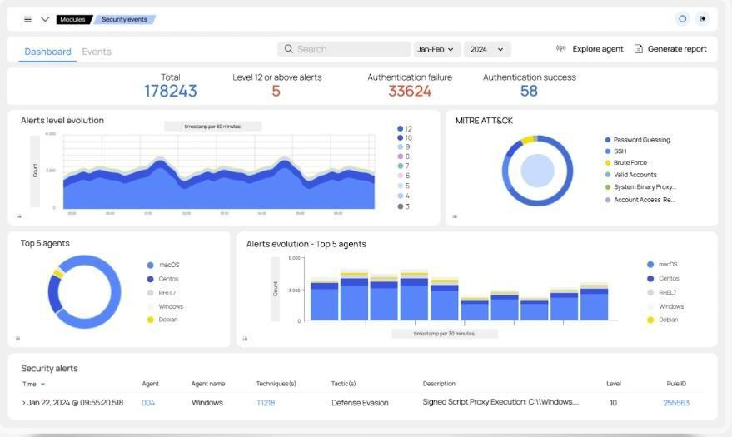
Figure 13.1

Alerts Logs:
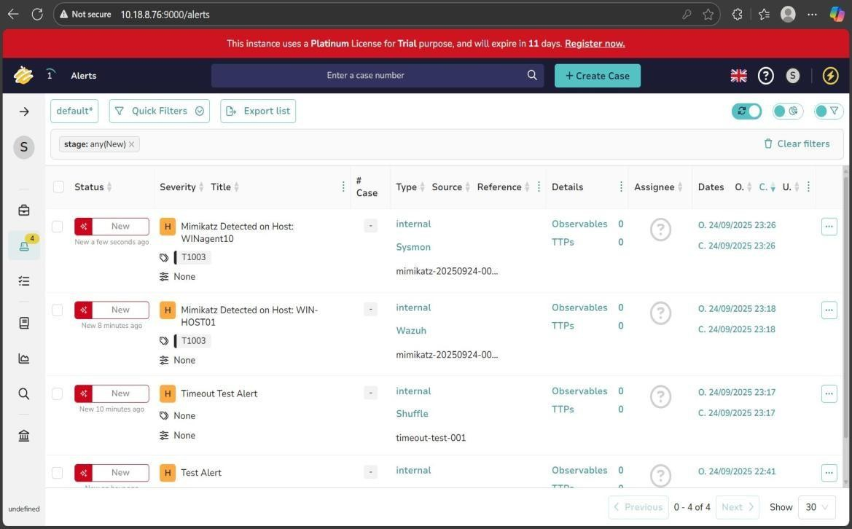
Figure 13.2

User Agents
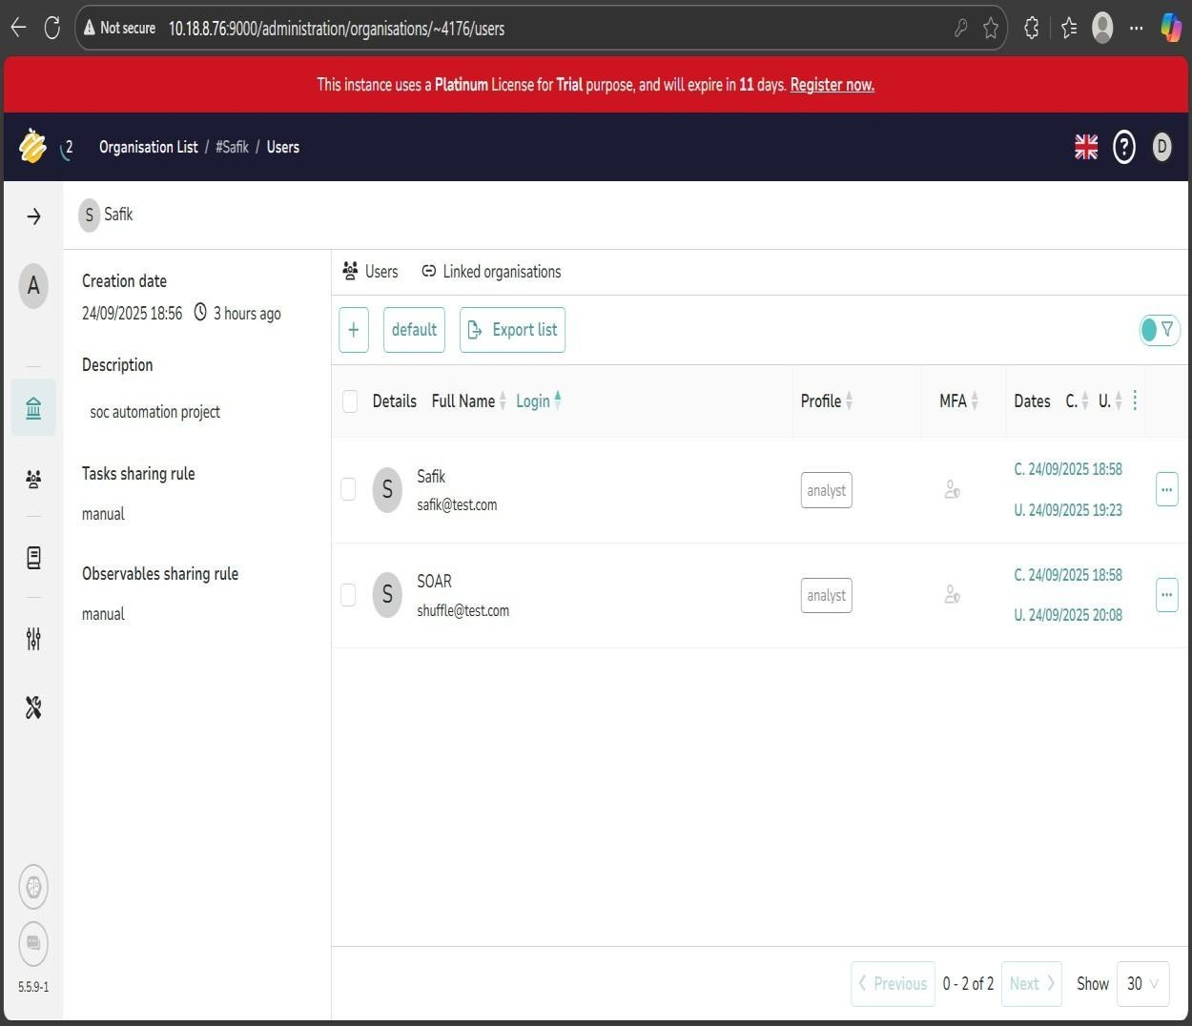

Figure 13.3

Events:
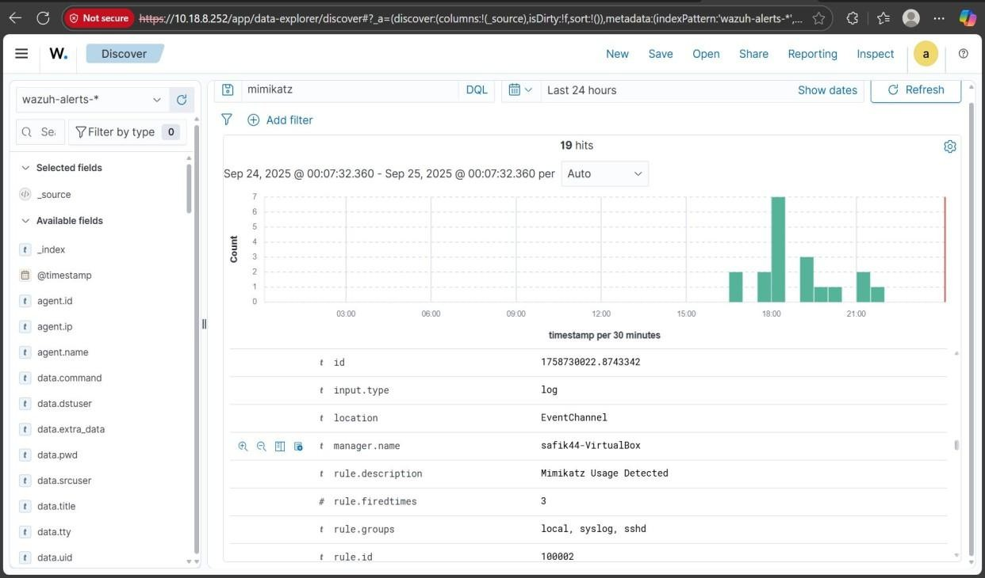
Figure 13.4

Response:
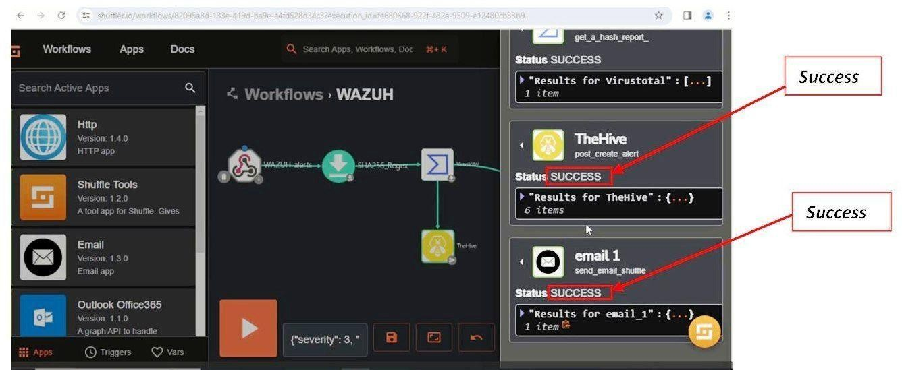

Figure 13.5

Update Dashboard:
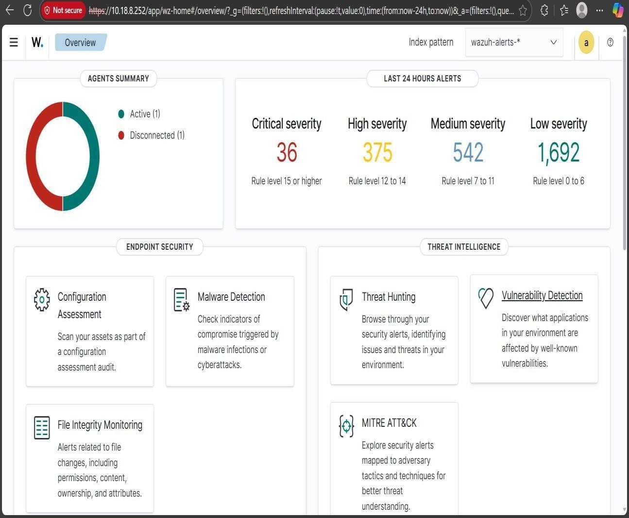

Figure 13.6

CHAPTER 14
METRICS, BENCHMARKS and SCALABILITY ANALYSIS

Detection Metrics:

Metric | Description
True Positives | Correctly identified threats
False Positives | Benign events flagged as threats
False Negatives | Missed threats
Precision | \frac{TP}{TP + FP}
Recall | \frac{TP}{TP + FN}
F1 Score | Harmonic mean of precision and recall
Table 14.1

Alert Latency
  - Measures time from threat occurrence to alert delivery.
  - Target: < 5 seconds for critical alerts.

Workflow Execution Time (Shuffle)
  - Time to complete automated response (e.g., enrichment + case creation).
  - Target: < 10 seconds end-to-end.

System Resource Metrics

Component | Metric | Target
Wazuh Manager | CPU Usage | < 70%
Wazuh Manager | Memory Usage | < 4 GB
Shuffle Worker | API Call Latency | < 2 seconds
Shuffle Worke | Queue Backlog | < 10 items

Table 14.2

Scalability Metrics

Metric | Description
Agent Throughput | Alerts/sec with increasing agents
Workflow Concurrency | Parallel executions without failure
API Rate Limits | External service limits (e.g., VirusTotal)
Horizontal Scaling | Adding workers/nodes to handle load

Table 14.3

Benchmarks (Sample Observations):

Scenario | Observed  Value | Benchmark  Target | Status
Alert Latency (Sysmon → Wazuh) | 2.8 sec | ≤ 5 sec | Good
Shuffle Workflow (VT + Hive | 6.5 sec | ≤ 10 sec | Good
CPU Usage (Wazuh Manager) | 78% | ≤ 70% | High
Memory Usage (Shuffle Worker) | 2.2 GB | ≤ 3 GB | Stable
API Failures  (VirusTotal) | 0.5% | ≤ 1% | Stable

Table 14.4

Detections:
Figure 14.1

Scalability Analysis

Load Simulation
Method: Simulate increasing agent count (e.g., 100 → 500 → 1000).
Tools: Apache JMeter, Wazuh-logtest, custom log generators.

Observations

Count | Alerts | Wazuh | Shuffle
100 | 12 | 45% | 2
500 | 58 | 72% | 7
1000 | 110 | 88% | 15
Table 14.5

Bottlenecks Identified
  - Wazuh Manager CPU saturation at >800 agents.
  - Shuffle queue backlog when workflows exceed 10/sec.
  - External API rate limits (VirusTotal, TheHive).

Optimization Strategies
  - Enable multi-threaded decoding in Wazuh.
  - Deploy multiple Shuffle workers with load balancing.
  - Use caching for repeated enrichment queries.
  - Implement alert filtering to reduce noise.

CHAPTER 15

CHALLENGES AND MITIGATION STRATEGIES

Webhook Misconfiguration
  - Challenge: Wazuh alerts may not reach Shuffle due to incorrect webhook URLs or payload formats.

Mitigation:
  - Validate webhook endpoints with test payloads.
  - Use logging in Shuffle to trace incoming requests.
  - Implement retry logic or buffering in Wazuh’s active-response scripts.

Data Format Incompatibility
  - Challenge: Wazuh JSON alerts may not match Shuffle’s expected schema.

Mitigation:
  - Use Shuffle’s pre-processing nodes to normalize data.
  - Create custom parsers or mapping templates.
  - Maintain version control for alert schemas.

Tool Interoperability
  - Challenge: Shuffle workflows may fail when integrating with external tools (e.g., TheHive, VirusTotal).

Mitigation:
  - Use API health checks before triggering actions.
  - Implement fallback paths in workflows.
    - Monitor rate limits and apply throttling.

False Positives & Mitigation:
    - Overly Broad Detection Rules
      - Challenge: Wazuh may flag benign activity due to generic rules (e.g., PowerShell usage).

Mitigation:
      - Refine rules using contextual filters (e.g., parent process, user role).
      - Use threat intelligence enrichment (via Shuffle) to validate observables.
      - Apply suppression rules for known safe behaviors.

Alert Fatigue
      - Challenge: Analysts overwhelmed by non-actionable alerts.

Mitigation:
      - Prioritize alerts using severity levels and asset criticality.
      - Auto-close low-risk alerts via Shuffle workflows.
      - Use machine learning models to score alert relevance (optional advanced step).

Duplicate Alerts
      - Challenge: Same event triggers multiple alerts across agents.

Mitigation:
      - Use deduplication logic in Shuffle.
      - Correlate alerts based on timestamp, source IP and hash values.

Resource Constraints & Mitigation

- Wazuh Manager Overload
  - Challenge: High CPU/memory usage with large agent fleets.

Mitigation:
  - Enable multi-threaded decoding.
  - Offload logs to Elasticsearch with optimized indexing.
  - Use agent groups to segment rule application.

Shuffle Workflow Bottlenecks
  - Challenge: Slow execution due to sequential API calls.

Mitigation:
  - Use parallel nodes in Shuffle.
  - Deploy multiple Shuffle workers with load balancing.
  - Cache enrichment results for repeated observables

External API Rate Limits
  - Challenge: VirusTotal, TheHive, etc. may throttle requests.

Mitigation:
  - Monitor API usage and apply backoff strategies.
  - Use premium tiers if needed.
  - Queue enrichment tasks during peak hours.

Summary Table:

Challenge | Mitigation Strategy
Webhook failures | Validate endpoints, add retries
Format mismatch | Normalize data in Shuffle
API integration errors | Health checks, fallback paths
False positives | Contextual rules, enrichment, suppression
Alert fatigue | Prioritization, auto-close, ML scoring
Wazuh resource overload | Threading, log offloading, agent grouping
Shuffle bottlenecks | Parallel workflows, worker scaling
API rate limits | Throttling, caching, premium tiers

Table 15.1

CHAPTER 16
CONCLUSION AND FUTURE ENHANCEMENTS

Future Enhancements
- Machine Learning Integration
  - Add ML-based anomaly detection (e.g., using ELK + ML plugins or custom models).
  - Use supervised learning to reduce false positives.

Dynamic Rule Management
  - Implement rule versioning and auto-tuning based on feedback loops.
  - Use threat intelligence feeds to update Wazuh rules dynamically.

Workflow Optimization
  - Introduce modular workflow templates in Shuffle for reuse.
  - Add conditional branching and error handling for robustness.

Scalability Improvements
  - Deploy Wazuh in a clustered architecture.
  - Use containerized Shuffle workers with autoscaling (e.g., via Kubernetes).

Enhanced Enrichment
  - Integrate additional sources: AbuseIPDB, GreyNoise, Shodan.
  - Cache enrichment results to reduce API load.

Security Hardening
  - Enforce authentication and encryption for all webhook and API communications.
  - Audit Shuffle workflows for privilege escalation risks.

Visualization & Reporting
  - Build Grafana dashboards for real-time metrics.
  - Generate automated incident reports from Shuffle workflows.

Current Limitations

Area | Limitation Description
Alert Noise | High false positive rate due to generic detection  rules.
Resource  Bottlenecks | Wazuh manager and Shuffle workers may saturate  under load.
API Rate  Limits | External services (e.g., VirusTotal) throttle high-  volume queries.
Workflow  Complexity | Shuffle workflows can become hard to maintain at  scale.
Lack of ML  Intelligence | No native anomaly detection or behavioral  analysis.
Manual  Rule Tuning | Wazuh rules require ongoing refinement and  testing.
Table 16.1

Conclusion
The integration of Wazuh (SIEM/XDR) and Shuffle (SOAR) provides a robust, scalable and modular framework for real-time threat detection and automated incident response. This system enables:

  - Continuous monitoring of endpoints and network activity.
  - Automated enrichment and triage using Shuffle workflows.
  - Seamless case management via integrations with platforms like TheHive.
  - Reduced analyst fatigue through alert prioritization and auto-response.
This architecture supports both small-scale deployments and enterprise-grade SOC environments, offering flexibility, transparency and extensibility.

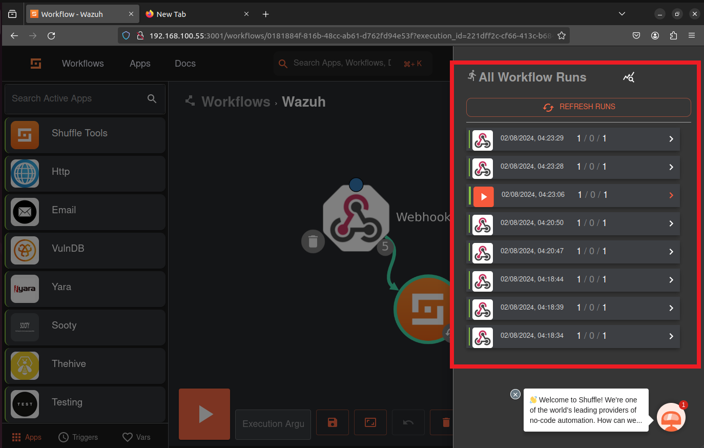
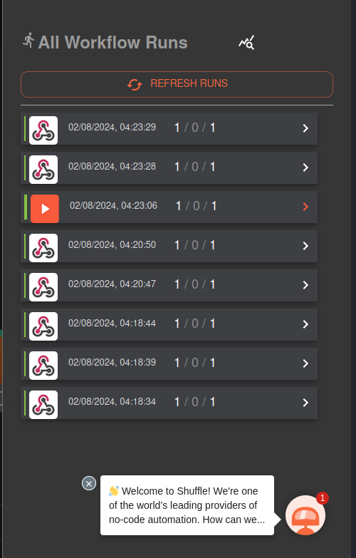
ATPENDIX
a

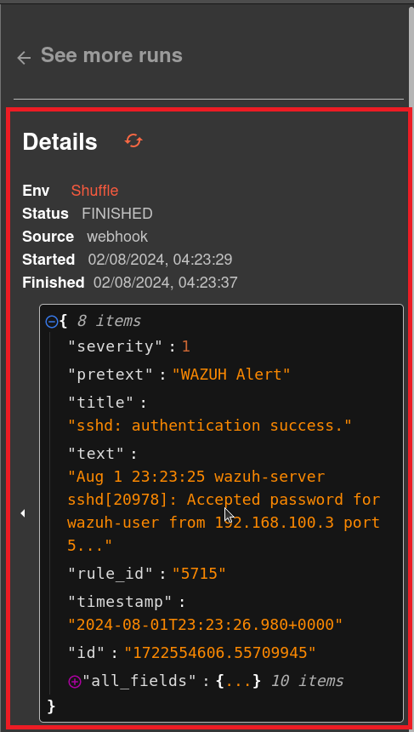

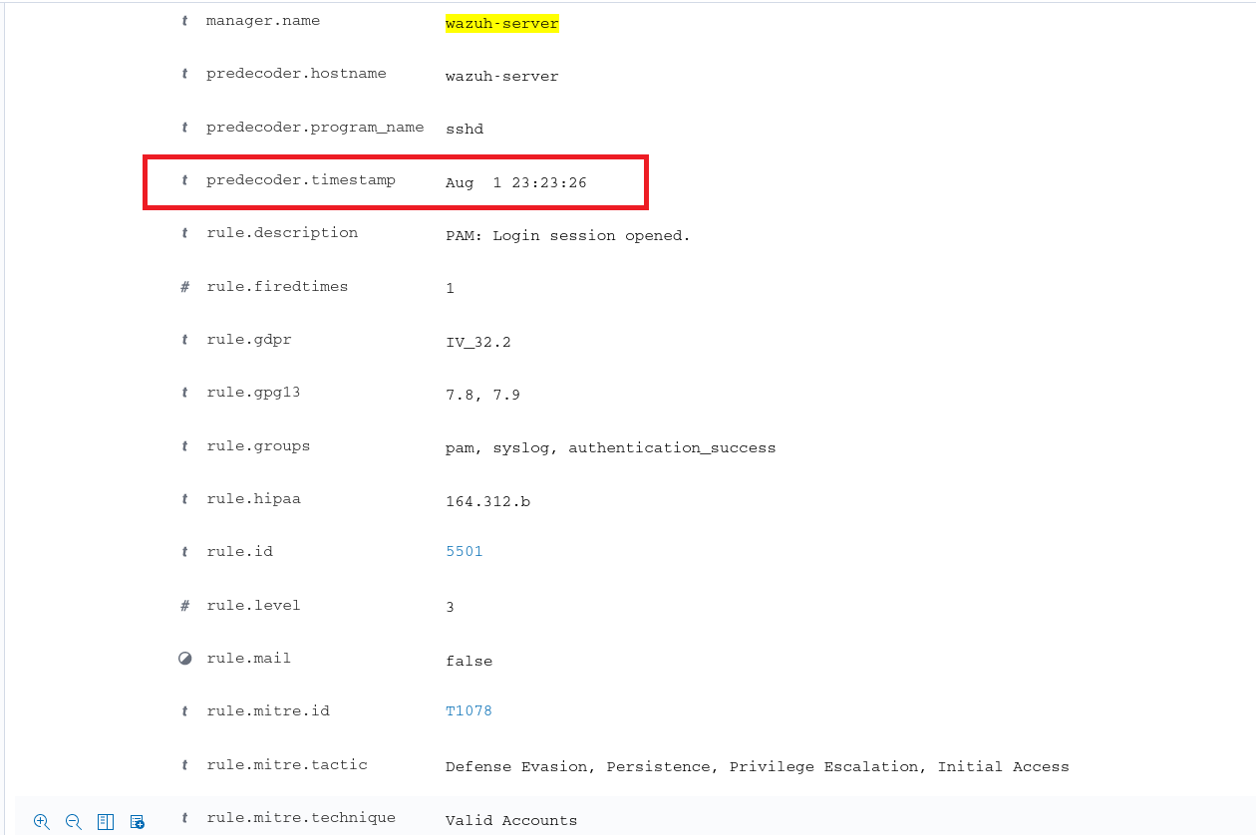
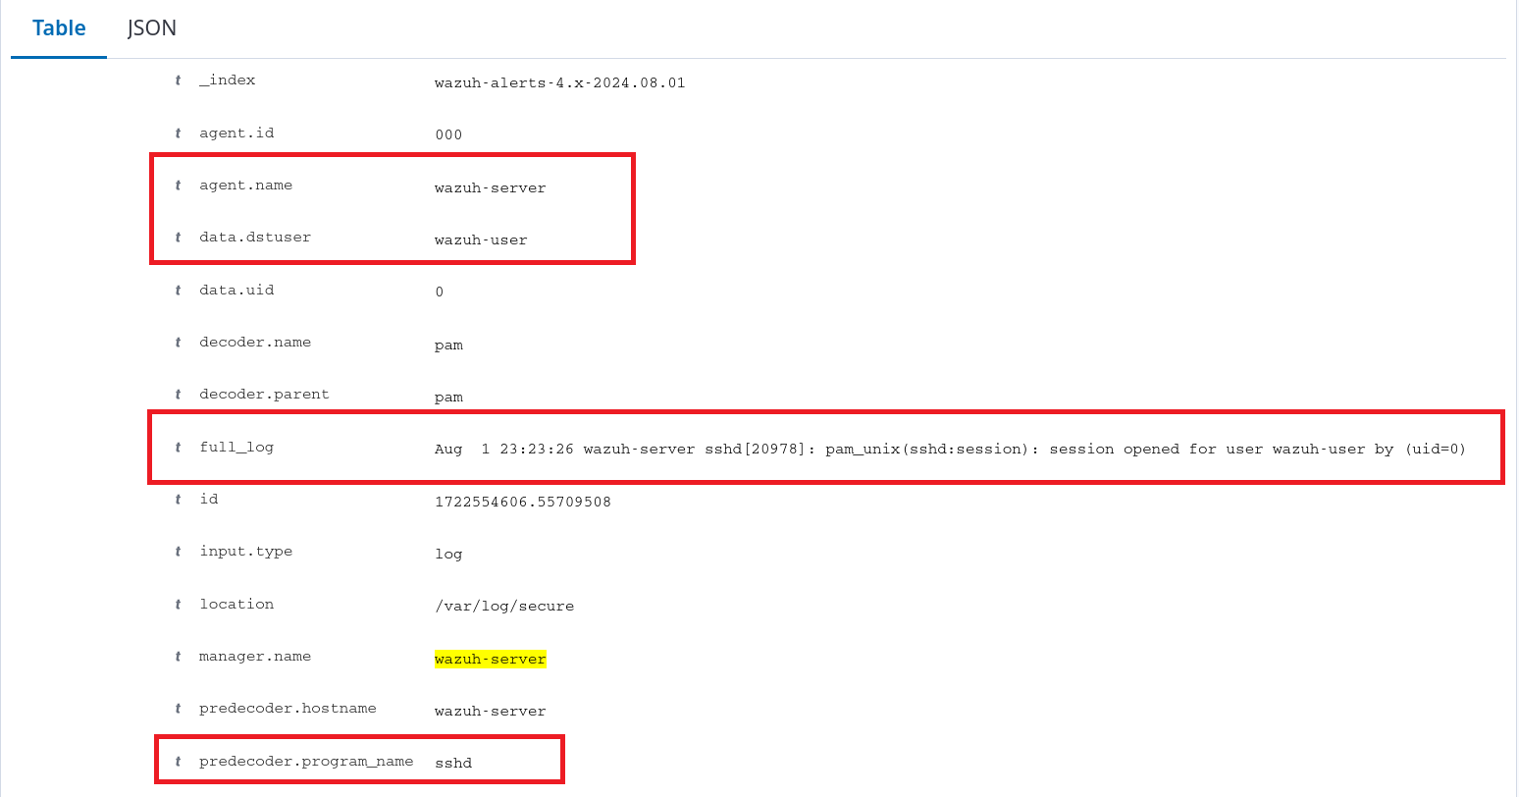

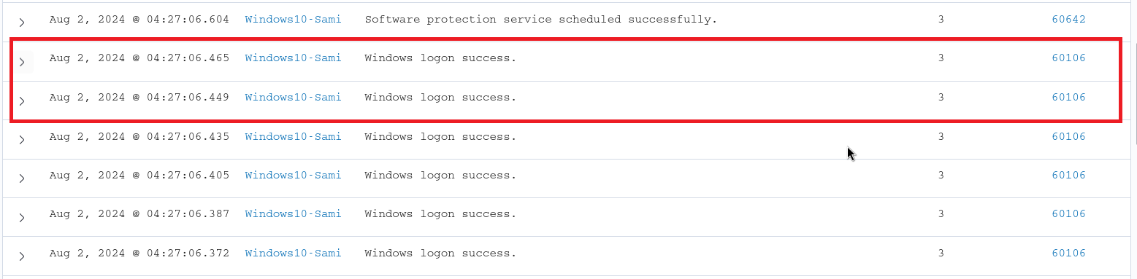
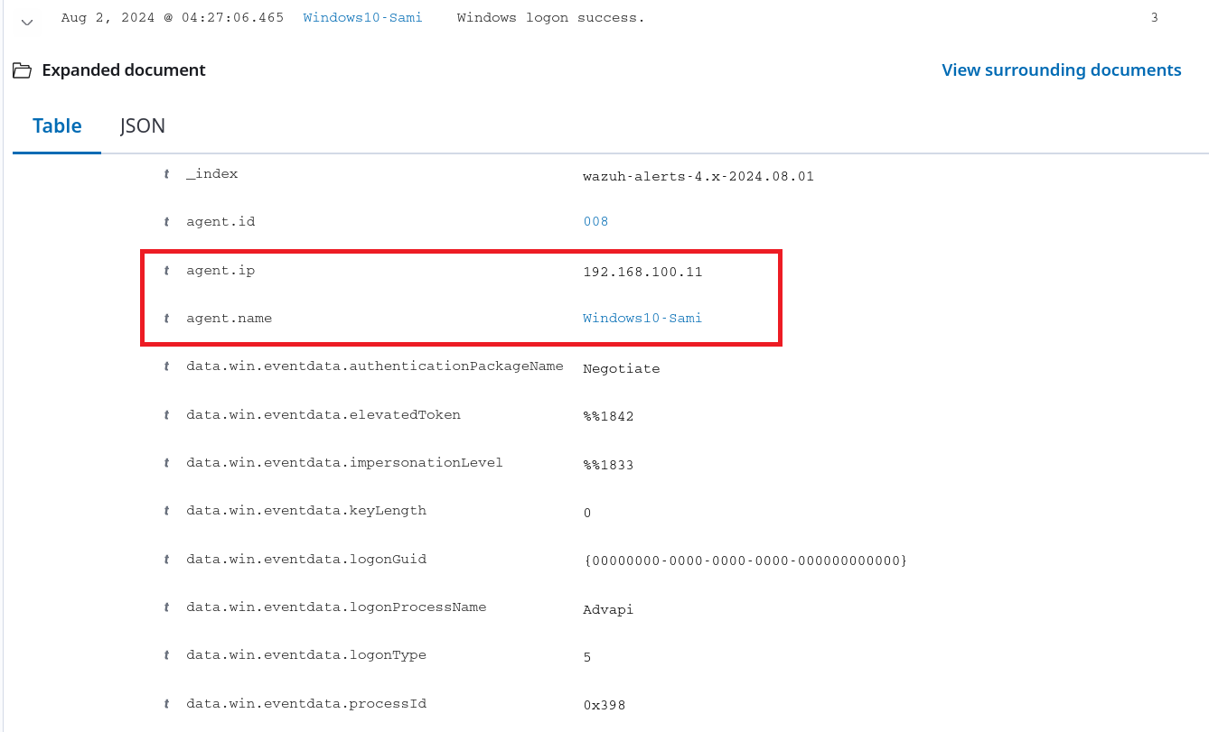
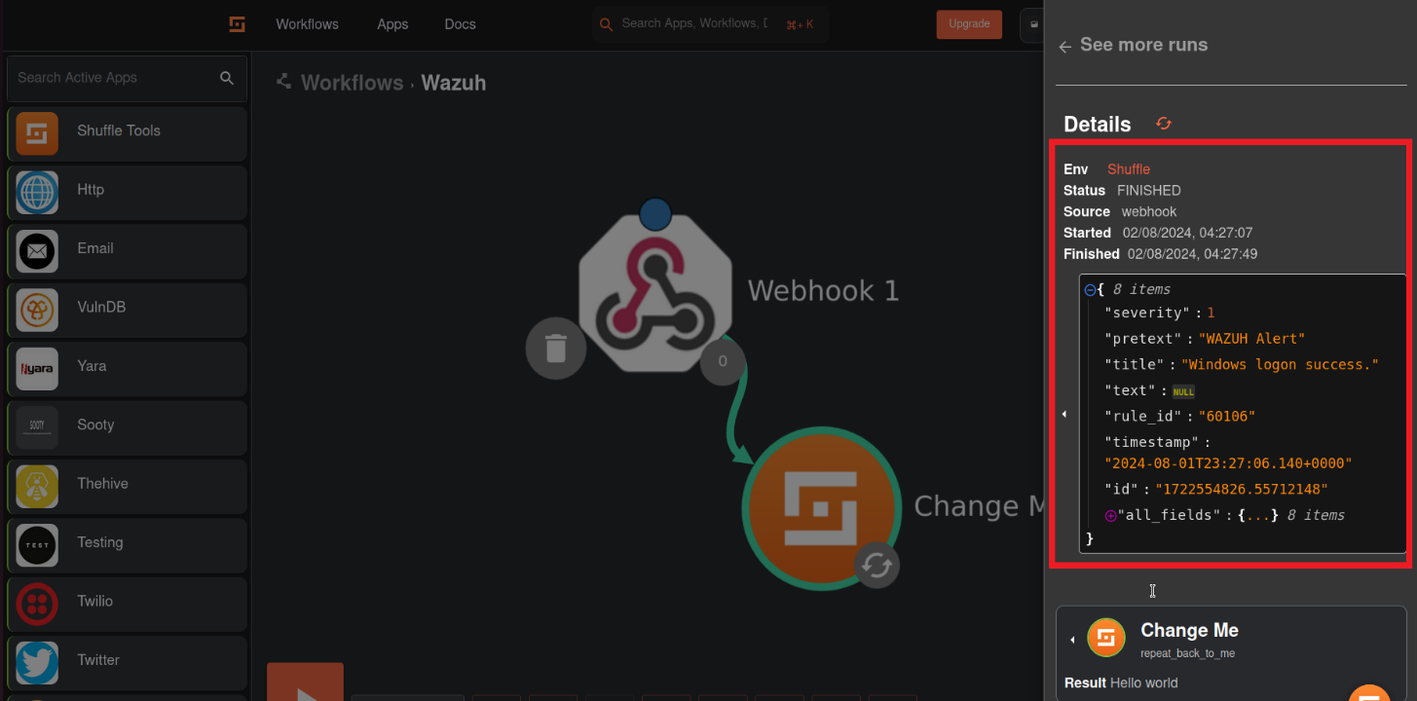
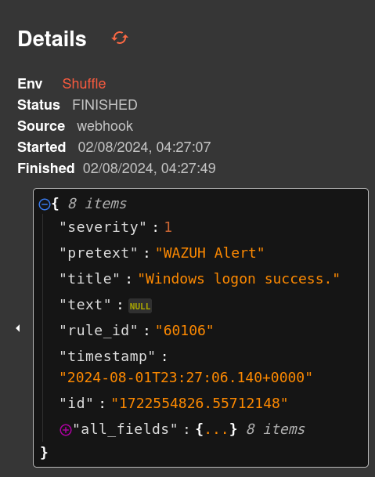

REFERENCES

1.Sharma and V. Gupta, “A comparative study of open-source SIEM tools for real- time threat detection,”
International Journal of Computer Applications, vol. 182, no. 12, pp. 25–30, 2023.

2.Singh, R. Verma and T. Kaur, “Automated incident response using Shuffle and open-source threat intelligence,” International Journal of Cybersecurity Intelligence & Cybercrime, vol. 5, no. 1, pp. 45–52, 2024.

3.Wazuh Documentation. “Wazuh: The Open Source Security Platform.” [Online]. Available: https://documentation.wazuh.com/

4. Shuffle SOAR. “Low-Code Security Automation for Everyone.” [Online]. Available: https://shuffler.io/

5.NIST Special Publication 800-207, “Zero Trust Architecture,” National Institute of Standards and Technology, Aug. 2020. [Online]. Available: https://doi.org/10.6028/NIST.SP.800-207

6.A. Kumar and S. Singh, “Implementation of SIEM Using Open Source Tools for Real-Time Threat Detection,” International Journal of Advanced Computer Science and Applications, vol. 14, no. 2, pp. 45–52, 2024.

7.M. O’Connor, “Cybersecurity Threat Detection and Response Using Wazuh and Open Source Tools,” National College of Ireland Thesis Repository, 2023.

8.S. Raj and P. Mehta, “Designing a Security Operations Center Using Wazuh, Shuffle and TheHive,” JETIR, vol. 11, no. 5, pp. 120–126, May 2024.

9.IBM Security, “The Evolution of Zero Trust and the Frameworks That Guide It,” IBM Think Insights, 2024. [Online]. Available: https://www.ibm.com/think/insights/the-evolution-of-zero-trust-and-the-frameworks-that-guide-it

10.A. Sharma, “Exploring the Implementation and Challenges of Zero Trust Security Models,” IJERT, vol. 14, no. 5, pp. 146–152, 2025. [Online]. Available: https://www.ijert.org/research/exploring-the-implementation-and-challenges-of-zero-trust-security-models-in-modern-network-environments-IJERTV14IS050146.pdf.

